Release Notes

Updation of VGM from Flatfile EDI from APL

Prepared for
Pasha Group,
4040 Civic Center Dr,
San Rafael, CA 94903
Table of Contents
1. Updation of VGM from Flatfile EDI from APL 3
2. Client Requirement: 3
3. Scope 3
4. Configuration: 4
4.1. Field Override: (If Field not exists already) 4
4.2. General Reference: 5
4.3. Add Code Extension: 6
4.4. ADD EDI Message Map 7
4.5. ADD Trading Partner (If not exist already) 7
4.6. ADD EDI Mailboxes 8
4.7. ADD EDI Sessions 8
4.8. Groovy Code 9
4.9. Mapping: 13
4.10. EDI Dictionary Files: 14
4.11. EDI Map Files: 14
5. Test Cases: 14
5.1. Steps to Load EDI: 28
6. Screengrabs: 29

Updation of VGM from Flatfile EDI from APL

Enhancement to upload a text / csv file delimited with coma (,) at the unit level and update the VGM weight in LBS.

Client Requirement:
- Upload text / csv file
- Update VGM Weight from to VGM Flex Field (unitFlexString12) if Export Active Full Unit exist for the given Booking / Vessel Visit.
- VGM Flex Field (unitFlexString12) should always be updated LBS.
- If no Active Export Full Unit found associated with given booking number or vessel visit, then raise error in EDI Batch.

Scope

Configure Trading Partner : |  |  | APLUPROD
Configure Mail Box : |  |  | APL FLATFILE MAILBOX
Configure Message Type : |  |  | APL FLATFILE
Configure EDI Session : |  |  | APL FLATFILE
Create EDI_POST_INTERCEPTOR: |  |  | PashaUpdateVGMWeightToFlexField
APL FlatFile received in Mailbox is mapped, but not posted by Session

EDI_POST_INTERCEPTOR “PashaUpdateVGMWeightToFlexField “ updates the units on following logic
a) | If the Ective Export Full Unit is found and associated to booking number in EDI
 | - The VGM Flex Field (unitFlexString12) is updated with VGM Weight received in EDI in LBS.
 | - The EDI batch is Set to COMPLETE
b) | If the Visit state is other than Active or If the unit does not attached to booking number from EDI,
 | - The EDI batch is set to ERROR
c) | If the EDI posted without VGM weight or invalid weight unit
d) | - The EDI batch is set to ERROR  If the EDI posted with line operators other than “APL” or “AEX”  - The EDI batch is set to ERROR  d

Configuration:

Field Override: (If Field not exists already)
Location: Administration→Settings→Fields

- Override the Unused Unitflexstring fields (unitFlexString12) in Fields tab.
- Override the field in Complex Level.
- Add the field in the Group Id Contents.

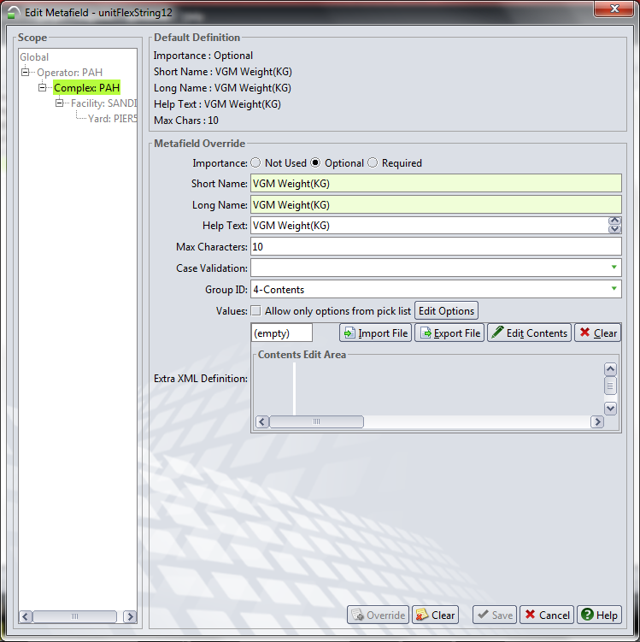

Select Actions→Reset
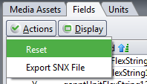

Select Propagate change to all nodes & click OK

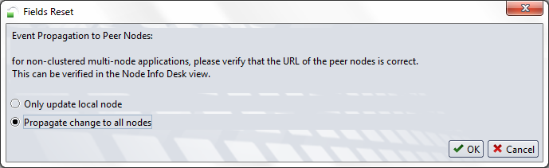

General Reference:

User can configure the line operators with dummy line operators in General Reference.User can give upto 6 dummy line operators.

Configuration>>Other>>General Reference
Type: FLAT_FILE_LINE_OP
Identifier 1: APL
DataValue1: AEX
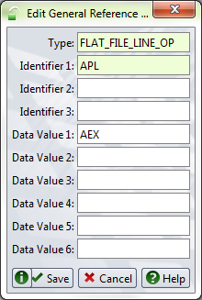

Add Code Extension:

Administration >> Systems >> Code Extensions

Code Extension Name : PashaUpdateVGMWeightToFlexField
Level : Facility
Scope : Current Scope
Extension Type : EDI_POST_INTERCEPTOR
Extension Language : Groovy

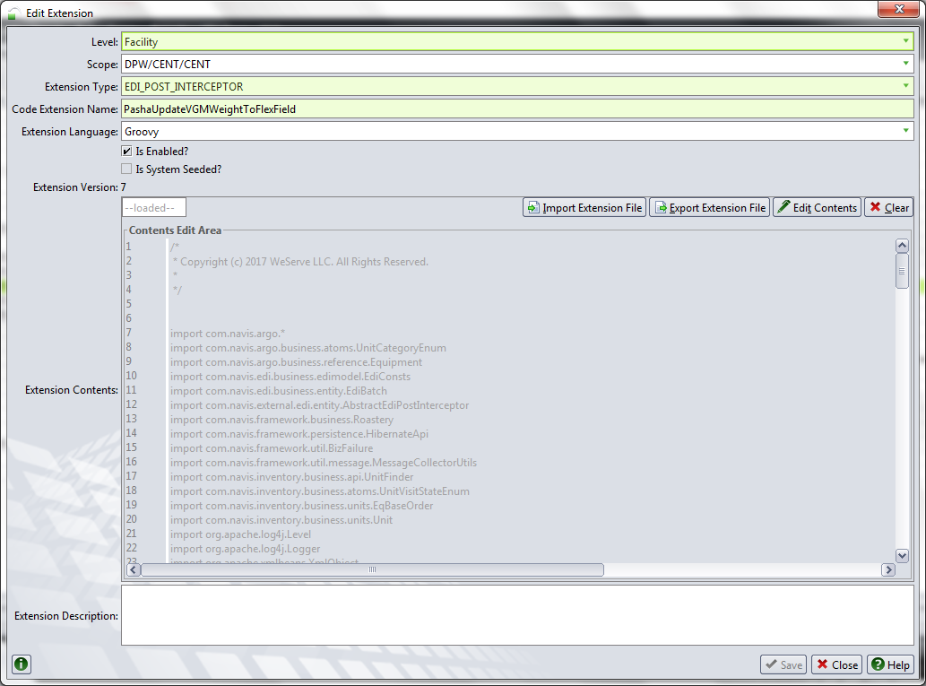

ADD EDI Message Map

EDI Message Type is created with Name as “PREADVISE” and Message Map is loaded with MGP and DIC files.

Map Id : APL FLATFILE

Direction : Receive
Import DIC : FlatFile_Final_in.dic
Import MGT : FlatFile_Final_in.mgp

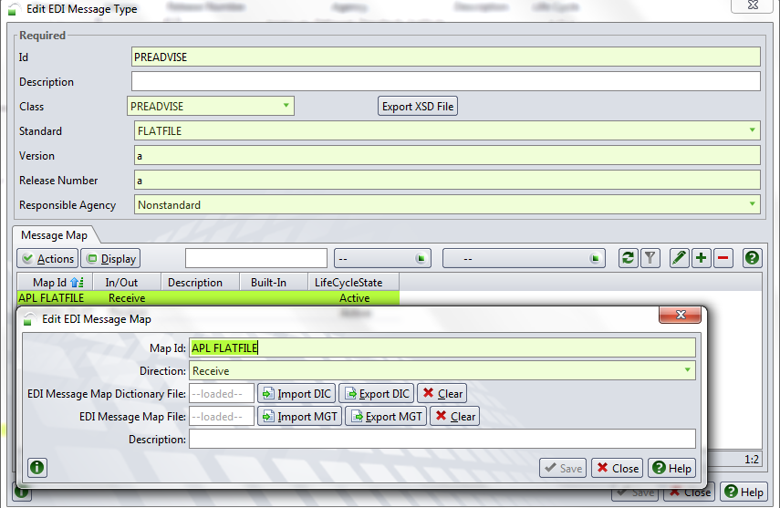

ADD Trading Partner (If not exist already)
Administration >> EDI >> Trading Partners

Partner Name : APLUPROD

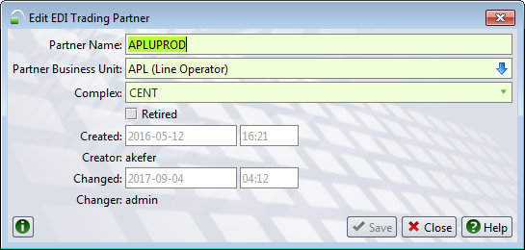

ADD EDI Mailboxes
Administration >> EDI >> EDI Mailboxes

Mailbox Name : APL FLATFILE MAILBOX
Direction : Receive

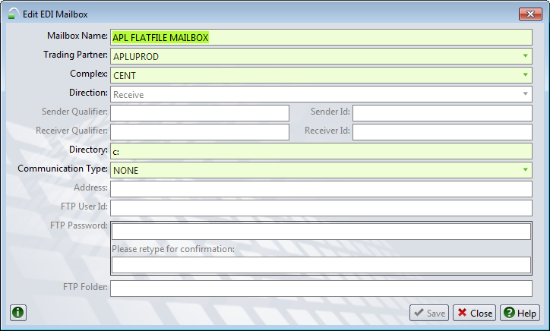

ADD EDI Sessions

Administration >> EDI >> EDI Sessions

Name : APL FLATFILE
Direction : Receive
Primary Mailbox : APL FLATFILE MAILBOX
Message Type : APL FLATFILE
Post Code Extension : PashaUpdateVGMWeightToFlexField

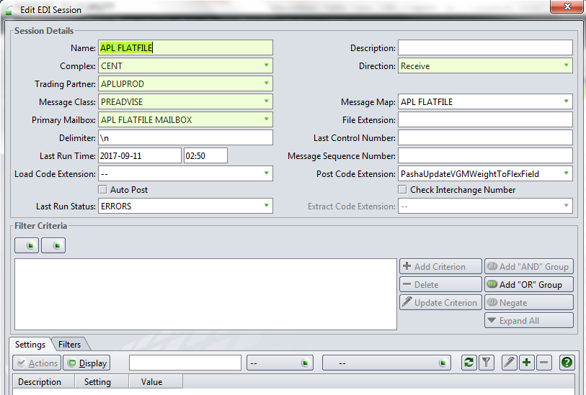

Groovy Code

PashaUpdateVGMWeightToFlexField.groovy

/*
* Copyright (c) 2017 WeServe LLC. All Rights Reserved.
*
*/

import com.navis.argo.ArgoPropertyKeys
import com.navis.argo.ContextHelper
import com.navis.argo.EdiBooking
import com.navis.argo.EdiCarrierVisit
import com.navis.argo.EdiContainer
import com.navis.argo.EdiFlexFields
import com.navis.argo.EdiVesselVisit
import com.navis.argo.PreadviseTransactionDocument
import com.navis.argo.PreadviseTransactionsDocument
import com.navis.argo.business.atoms.FreightKindEnum
import com.navis.argo.business.atoms.UnitCategoryEnum
import com.navis.argo.business.model.CarrierVisit
import com.navis.argo.business.model.GeneralReference
import com.navis.argo.business.reference.EquipType
import com.navis.argo.business.reference.Equipment
import com.navis.argo.business.reference.LineOperator
import com.navis.edi.business.edimodel.EdiConsts
import com.navis.edi.business.entity.EdiSession
import com.navis.external.edi.entity.AbstractEdiPostInterceptor
import com.navis.framework.business.Roastery
import com.navis.framework.business.atoms.MassUnitEnum
import com.navis.framework.persistence.HibernateApi
import com.navis.framework.util.BizFailure
import com.navis.framework.util.message.MessageCollectorUtils
import com.navis.framework.util.unit.UnitUtils
import com.navis.inventory.business.api.UnitFinder
import com.navis.inventory.business.units.EqBaseOrder
import com.navis.inventory.business.units.Unit
import com.navis.vessel.business.schedule.VesselVisitDetails
import org.apache.xmlbeans.XmlObject

/**
* This Edi Post Interceptor is written to update the flex field "UnitFlexString12" with VGM Weight.
* If the weight is given in LB's it will update the same, if the weight is given in KG's value will be updated by
* multiplying with 2.20462.
*
* This interceptor will skip the poster
*/

/*
*
* @Author <a href="mailto:peswendra@weservetech.com">Eswendra Reddy</a>, 08/Sep/2017
*
* Requirements : This groovy is used to update the flex field "UnitFlexString12" with VGM Weight.
* If the weight is given in LB's it will update the same, if the weight is given in KG's value will be updated by
* multiplying with 2.20462.
*
* @Inclusion Location : code extension need to tied to EDI Session under Post Code Extension as mention below.
*
* Deployment Steps:
* a) Administration -> System -> Code Extension
* b) Click on + (Add) Button
* c) Add as EDI_POST_INTERCEPTOR and code extension name as PashaUpdateVGMWeightToFlexField
* d) Paste the groovy code and click on save
*
*/

class PashaUpdateVGMWeightToFlexField extends AbstractEdiPostInterceptor {

@Override
public void beforeEdiPost(XmlObject inXmlTransactionDocument, Map inParams) {
log("Inside PashaUpdateVGMWeightToFlexField :: START");
Serializable sessionGKey = (Serializable) inParams.get(EdiConsts.SESSION_GKEY);
log("Current EDI Session Gkey :: $sessionGKey")
EdiSession ediSession = (EdiSession) HibernateApi.getInstance().load(EdiSession.class, sessionGKey);
LineOperator sessionLineOperator;
if (ediSession.getEdisessTradingPartner().getEdiptnrBusinessUnit() != null) {
sessionLineOperator = LineOperator.resolveLineOprFromScopedBizUnit(ediSession.getEdisessTradingPartner().getEdiptnrBusinessUnit());
log("Current EDI Session Line Operator :: $sessionLineOperator")
}

inParams.put(EdiConsts.SKIP_POSTER, Boolean.TRUE);
PreadviseTransactionsDocument preAdviseDocument = (PreadviseTransactionsDocument) inXmlTransactionDocument;
PreadviseTransactionsDocument.PreadviseTransactions preAdviseTransactions = preAdviseDocument.getPreadviseTransactions();
List<PreadviseTransactionDocument.PreadviseTransaction> list = preAdviseTransactions.getPreadviseTransactionList();
if (list.isEmpty()) {
throw BizFailure.create("There is no transaction in the batch");
}
try {
for (PreadviseTransactionDocument.PreadviseTransaction preAdviseTransaction : list) {
Unit activeUnit
if (canProceedToUpdate(activeUnit, preAdviseTransaction, sessionLineOperator)) {
log("Active Unit :: " + activeUnit);
activeUnit = getUnit(preAdviseTransaction.getEdiContainer().getContainerNbr())
EdiContainer ctr = preAdviseTransaction.getEdiContainer()
Equipment equipment = activeUnit.getUnitEquipment();
log("Current Equipment :: " + equipment);
String ctrGrossWt = ctr.getContainerGrossWtUnit();

Double ctrTareWt = 0.0D;
ctrTareWt = equipment.getEqTareWeightKg();

Double ctrSafeWt = 0.0D;
ctrSafeWt = equipment.getEqSafeWeightKg();

EquipType eqType = equipment.getEqEquipType();

String tareWtLbVal = convertKGtoLB(ctrTareWt.toString());
long tareWtRoundedVal = Math.round(tareWtLbVal.toDouble());

if (FreightKindEnum.MTY.equals(activeUnit.getUnitFreightKind())) {
log("Freight Kind is Empty, updating Equipment Tare Wt" + equipment.getEqTareWeightKg());
if (ctrTareWt == 0.0D) {
Double eqTypeTareeWt = eqType.getTareWeightKg();
if (eqTypeTareeWt == 0.0D) {
EdiFlexFields flexFields = preAdviseTransaction.getEdiFlexFields();
if (flexFields == null) {
appendToMessageCollector("There is no Weight to update");
log("There is no Weight to update");
} else {
String VgmWt = flexFields.getUnitFlexString12();
if (VgmWt == null) {
appendToMessageCollector("There is no Weight to update");
log("There is no Weight to update");
}
//restore the value before converting the VGM value into KG's so that up on rouding there will not
//be any difference.
String actualVgmWt = covertVGMWtKgToLb(ctrGrossWt, VgmWt);
activeUnit.setUnitFlexString12(actualVgmWt);
}
} else {
String eqTypeTareeWtLbVal = convertKGtoLB(eqTypeTareeWt.toString());
long eqTypeTareeWtRoundedVal = Math.round(eqTypeTareeWtLbVal.toDouble());
activeUnit.setUnitFlexString12(eqTypeTareeWtRoundedVal.toString());
}
} else {
activeUnit.setUnitFlexString12(tareWtRoundedVal.toString());
}
} else if (FreightKindEnum.FCL.equals(activeUnit.getUnitFreightKind()) || FreightKindEnum.LCL.equals(activeUnit.getUnitFreightKind())) {
log("Inside FCL/LCL condition");
EdiFlexFields flexFields = preAdviseTransaction.getEdiFlexFields();
if (flexFields == null) {
appendToMessageCollector("File Does not contain proper weight");
log("File Does not contain proper weight");
} else {
String VgmWt = flexFields.getUnitFlexString12();
if (VgmWt == null) {
appendToMessageCollector("File Does not contain proper weight");
log("File Does not contain proper weight");
}

//convert VGM field to KG based on ctrGrossWtUnit if it is in LB's for comparision with fields such
// as Equipment Tare Wt, Safe Wt, Equipment Type Safe Wt and Tare Wt, because by default fields
//above fields will come here in KG's.
String convertedVgmWt = weightConversionForVGM(ctrGrossWt, VgmWt);
Double vgmRoundedValue = convertedVgmWt.toDouble();

//convert VGM weight from KG to LB inorder to update to flex field
String roundedValue = convertKGtoLB(convertedVgmWt);
long lbRoundedVal = Math.round(roundedValue.toDouble());

//restore the value before converting the VGM value into KG's so that up on rouding there will not
//be any difference.
String actualVgmWt = covertVGMWtKgToLb(ctrGrossWt, VgmWt);

//Tare Wt comparision
if (ctrTareWt == 0.0D) {
Double eqTypeTareWt = eqType.getTareWeightKg();
if (eqTypeTareWt == 0.0D) {
} else {
if (vgmRoundedValue < eqTypeTareWt) {
appendToMessageCollector("Weight is less Equipment Type tare weight");
log("Weight is less Equipment Type tare weight");
}
}
} else if (vgmRoundedValue < ctrTareWt) {
appendToMessageCollector("Weight is less tare weight");
log("Weight is less tare weight");
}

//Safe Wt comparision
if (ctrSafeWt == 0.0D) {
Double eqTypeSafeWt = 0.0D;
eqTypeSafeWt = eqType.getEqtypSafeWeightKg();

if (eqTypeSafeWt == 0.0D) {
activeUnit.setUnitFlexString12(actualVgmWt);
} else if (eqTypeSafeWt > 0.0D) {
if (vgmRoundedValue > eqTypeSafeWt) {
log("VgmRoundedValue " + vgmRoundedValue + "EqTypeSafeWt " + eqTypeSafeWt)
appendToMessageCollector("Weight is greater than equipment type safe weight");
log("Weight is greater than equipment type safe weight");
} else {
activeUnit.setUnitFlexString12(actualVgmWt);
}
}
} else {
log("Vgm Rounded Value " + vgmRoundedValue);
if (vgmRoundedValue > ctrSafeWt) {
appendToMessageCollector("Weight is greater than safe weight");
log("Weight is greater than safe weight");
} else {
activeUnit.setUnitFlexString12(actualVgmWt);
}
}
HibernateApi.getInstance().save(activeUnit);
HibernateApi.getInstance().flush();
}
} else {
ContextHelper.getThreadEdiPostingContext().throwIfAnyViolations();
}
}
}
} finally {
inParams.put(EdiConsts.SKIP_POSTER, Boolean.TRUE);
}
}

private boolean canProceedToUpdate(Unit inUnit, PreadviseTransactionDocument.PreadviseTransaction preAdviseTransaction, LineOperator inLineOperator) {
EdiContainer ctr = preAdviseTransaction.getEdiContainer();
if (ctr == null) {
appendToMessageCollector("File Does not contain container number")
return false;
}
if (ctr.getContainerNbr() == null) {
appendToMessageCollector("File Does not contain container number");
return false;
} else {
String ctrGrossWtUnit = ctr.getContainerGrossWtUnit();
inUnit = getUnit(ctr.getContainerNbr());
if (inUnit == null) {
appendToMessageCollector("Unit does not exists");
return false
}
if (!FreightKindEnum.MTY.equals(inUnit.getUnitFreightKind()) && ctrGrossWtUnit == null) {
appendToMessageCollector("File Does not contain Container Gross Weight");
return false;
}
if (!FreightKindEnum.MTY.equals(inUnit.getUnitFreightKind()) && ctrGrossWtUnit.equals("QT") || ctrGrossWtUnit.equals("LT") || ctrGrossWtUnit.equals("ST") || ctrGrossWtUnit.equals("MT")) {
appendToMessageCollector("Weight type is not correct");
return false;
}
if (inUnit.getUnitLineOperator() != null && inLineOperator != null) {
log("Unit Line Operator :: " + inUnit.getUnitLineOperator() + " and session Line Operator :: " + inLineOperator)
if (!(inUnit.getUnitLineOperator().equals(inLineOperator))) {
GeneralReference lineOpGenRef = GeneralReference.findUniqueEntryById(LINE_OP_GEN_REF_ID, inLineOperator.getBzuId())
log("Line Operator Gen reference :: " + lineOpGenRef)
if (lineOpGenRef != null) {
if (allRefValuesEmpty(lineOpGenRef)) {
appendToMessageCollector("Line Operator mismatch with Unit");
return false
} else if (!matchesAnyRefValue(lineOpGenRef, inUnit.getUnitLineOperator().getBzuId())) {
appendToMessageCollector("Line Operator mismatch with Unit");
return false
}
} else {
appendToMessageCollector("Line Operator mismatch with Unit");
return false
}
}
} else {
appendToMessageCollector("Required fields (Unit Line Operator / Session Line Operator) missing)");
}
EqBaseOrder unitBooking = inUnit.getDepartureOrder();
if (unitBooking == null) {
appendToMessageCollector("No booking associated with Unit");
return false
}
EdiBooking ediBooking = preAdviseTransaction.getEdiBooking();
if (ediBooking == null) {
appendToMessageCollector("File Does not contain booking number");
return false;
}
if (!unitBooking.getEqboNbr().equals(ediBooking.getBookingNbr())) {
appendToMessageCollector("Booking mismatch with Unit");
return false
}

String outVoyageNbr = null;
String vesId = null;
String vesName = null;
EdiCarrierVisit vessel = preAdviseTransaction.getEdiOutboundVisit();
if (!FreightKindEnum.MTY.equals(inUnit.getUnitFreightKind())) {
if (vessel == null) {
appendToMessageCollector("File Does not contain OutVoyage / Lloyds / Vessel Name in Vessel Details");
return false;
} else if (vessel != null) {
EdiVesselVisit vesselVisit = vessel.getEdiVesselVisit();
if (vesselVisit != null) {
outVoyageNbr = vesselVisit.getOutVoyageNbr();
vesId = vesselVisit.getVesselId();
vesName = vesselVisit.getVesselName();
}
}
VesselVisitDetails vvd = null;
String unitsLlyodsId = null;
if (inUnit.getUnitActiveUfvNowActive() != null && inUnit.getUnitActiveUfvNowActive().getUfvActualObCv() != null) {
vvd = VesselVisitDetails.resolveVvdFromCv(inUnit.getUnitActiveUfvNowActive().getUfvObCv());
if (vvd != null && vvd.getVvdVessel() != null) {
unitsLlyodsId = vvd.getVvdVessel().getVesLloydsId();
if (!(vesId.equals(unitsLlyodsId))) {
appendToMessageCollector("Vessel Id / Lloyds Id mismatch with Unit");
return false;
} else if (!(outVoyageNbr.equals(vvd.getVvdObVygNbr()))) {
appendToMessageCollector("Outbound Voyage mismatch with Unit");
return false;
} else if (!(vesName.equals(vvd.getVvdVessel().getVesName()))) {
appendToMessageCollector("Vessel Name mismatch with Unit");
return false;
}
}
}
}
}
return true;
}

private boolean allRefValuesEmpty(GeneralReference generalReference) {
if (generalReference.getRefValue1() == null && generalReference.getRefValue2() == null && generalReference.getRefValue3() == null
&& generalReference.getRefValue4() == null && generalReference.getRefValue5() == null && generalReference.getRefValue6() == null) {
return true
}
return false
}

private boolean matchesAnyRefValue(GeneralReference generalReference, String inUnitLineOpId) {
if (inUnitLineOpId.equalsIgnoreCase(generalReference.getRefValue1()) || inUnitLineOpId.equalsIgnoreCase(generalReference.getRefValue2()) || inUnitLineOpId.equalsIgnoreCase(generalReference.getRefValue3())
|| inUnitLineOpId.equalsIgnoreCase(generalReference.getRefValue4()) || inUnitLineOpId.equalsIgnoreCase(generalReference.getRefValue5()) || inUnitLineOpId.equalsIgnoreCase(generalReference.getRefValue6())) {
return true
}
return false
}
/**
* To get the active export unit for the provided container number
*
* @param inCtrNbr
* @return
*/
private Unit getUnit(String inCtrNbr) {
Equipment eq = Equipment.findEquipment(inCtrNbr);
if (eq == null) {
appendToMessageCollector("Equipment does not exists");
log("Equipment does not exists");
}
UnitFinder unitFinder = (UnitFinder) Roastery.getBean(UnitFinder.BEAN_ID);
Unit unit = unitFinder.findActiveUnit(ContextHelper.getThreadComplex(), eq, UnitCategoryEnum.EXPORT);
return unit;
}

/**
* Method to Kilogram to convertPound
*
* @return
*/
private String convertKGtoLB(String inVgmWt) {
Double valueInLb = UnitUtils.convertTo(inVgmWt, MassUnitEnum.POUNDS, MassUnitEnum.KILOGRAMS);
log("valueInKg " + inVgmWt + " => valueInLb : " + String.valueOf(valueInLb));
return String.valueOf(valueInLb);
}

/**
* Method to Kilogram to convertPound
*
* @return
*/
private static String convertLBtoKG(String inVgmWt) {
Double valueInLb = UnitUtils.convertTo(inVgmWt, MassUnitEnum.KILOGRAMS, MassUnitEnum.POUNDS);
//log("valueInKg " + inVgmWt + " => valueInLb : " + String.valueOf(valueInLb));
return String.valueOf(valueInLb);
}

/**
* This method will convert the VGM weight to lb's
* @param inCtrGrossWt
* @param inVgmWt
* @param inActiveUnit
* @return
*/
private String weightConversionForVGM(String inCtrGrossWt, String inVgmWt) {
String roundedValue = new String();
if ("KG".equals(inCtrGrossWt)) {
log("KG value setting to flex field");
roundedValue = inVgmWt;
return roundedValue;
} else if ("LB".equals(inCtrGrossWt)) {
log("LB value setting to flex field");
roundedValue = convertLBtoKG(inVgmWt);
long lbRoundedVal = Math.round(roundedValue.toDouble());
return lbRoundedVal.toString();
}
return roundedValue;
}

/**
* This method will convert the VGM weight to lb's
* @param inCtrGrossWt
* @param inVgmWt
* @param inActiveUnit
* @return
*/
private String covertVGMWtKgToLb(String inCtrGrossWt, String inVgmWt) {
String roundedValue = new String();
if ("KG".equals(inCtrGrossWt)) {
log("KG value setting to flex field");
roundedValue = convertKGtoLB(inVgmWt);
long lbRoundedVal = Math.round(roundedValue.toDouble());
return lbRoundedVal.toString();
} else if ("LB".equals(inCtrGrossWt)) {
log("LB value setting to flex field");
roundedValue = inVgmWt;
return roundedValue;
}
return roundedValue;
}

/**
* Message Collector
* @param inMessage
*/
private static void appendToMessageCollector(String inMessage) {
MessageCollectorUtils.getMessageCollector().appendMessage(BizFailure
.create(ArgoPropertyKeys.INFO, null, inMessage));
}

private final String LINE_OP_GEN_REF_ID = "FLAT_FILE_LINE_OP";
}

Mapping:

EDI Segment | EDI Element | Expected Value | N4 Field Name | Output
Flatfile | /flat_text/record_set1/Flatfile/BookingNbr | bookingNbr | bookingNbr | bookingNbr
Flatfile | /flat_text/record_set1/Flatfile/BookingNbr | containerNbr | containerNbr | Container Number
Flatfile | vesselId | vesselId | vesselId | vesselId
Flatfile | /flat_text/record_set1/Flatfile/VGMWeight | unitFlexString12 | unitFlexString12 | unitFlexString12
Flatfile | /flat_text/record_set1/Flatfile/WeightUnit | containerGrossWtUnit | containerGrossWtUnit | containerGrossWtUnit
Flatfile | /flat_text/record_set1/Flatfile/OBVoyage | Ob Voyage | Outvoyagenbr | Outvoyagenbr
Flatfile | /flat_text/record_set1/Flatfile/vesselname | Vesname | Vesselname | Vesselname
Flatfile |  |  | msgClass | PREADVISE
Flatfile |  |  | containerOperator | AEX
Flatfile |  |  | vesselIDConvention | LLOYDS

EDI Dictionary Files:

- FlatFile_Final_in.dic

EDI Map Files:

- FlatFile_Final_in.mgp

Test Cases:

S. No | Test Scenario | Steps to be performed | Expected Result
1 | Flatfile with  - VGM weight in LB  - Export Active Full Unit Number  - Booking number & Vessel Visit ID associated to unit | 1. Select an Active Export Full Unit associated to a Booking Number & Vessel Visit  2. Load EDI with VGM Weight in LB, selected unit number, booking number & Vessel Visit ID | 1.unitFlexString12 of the selected Active Export Unit is updated with EDI VGM Weight.  2.Batch status Set to complete.
2 | Flatfile with  - VGM weight in LB  - Export Active LCL Unit Number  - Booking number & Vessel Visit ID associated to unit | 1. Select an Active Export LCL Unit associated to a Booking Number & Vessel Visit  2. Load EDI with VGM Weight in LB, selected unit number, booking number & Vessel Visit ID | 1.unitFlexString12 of the selected Active Export Unit is updated with EDI VGM Weight.  2.Batch status Set to complete.
3 | Flatfile with  - VGM weight in KG  - Export Active Full Unit Number  - Booking number & Vessel Visit ID associated to unit | 1. Select an Active Export Full Unit associated to a Booking Number & Vessel Visit  2. Load EDI with VGM Weight in KG, selected unit number, booking number & Vessel Visit ID | 1.unitFlexString12 of the selected Active Export Unit is updated with EDI VGM Weight converted to LB.  2.Batch status set to complete.
4 | Flatfile with  - VGM weight in KG  - Export Active LCL Unit Number  - Booking number & Vessel Visit ID associated to unit | 1. Select an Active Export LCL Unit associated to a Booking Number & Vessel Visit  2. Load EDI with VGM Weight in KG, selected unit number, booking number & Vessel Visit ID | 1.unitFlexString12 of the selected Active Export Unit is updated with EDI VGM Weight converted to LB.  2.Batch status set to complete.
5 | Flatfile with  - VGM weight in LB/KG  - Export Active Empty Unit Number  - Booking number & Vessel Visit ID associated to unit | 1. Select an Active Export Empty Unit associated to a Booking Number & Vessel Visit  2. Load EDI with VGM Weight, selected unit number, booking number & Vessel Visit ID | 1.unitFlexString12 of the selected Active Export Unit is updated with Equipment Tare Weight in LB.  2.Batch status Set to complete.
6 | Flatfile with  - VGM weight in LB/KG  - Export Active Empty Unit Number  - Booking number associated to unit  - Vessel visit ID is Empty{null} | 1. Select an Active Export Empty Unit associated to a Booking Number & Vessel Visit  2. Load EDI with VGM Weight, selected unit number, booking number & Vessel Visit ID as Empty{null} | 1.unitFlexString12 of the selected Active Export Unit is updated with Equipment Tare Weight in LB.  2.Batch status Set to complete.
7 | Flatfile with  - VGM weight in LB/KG  - Export Active Unit Number (Full/LCL/Empty)  - Booking number not associated to unit (or) unknown booking  - Vessel Visit ID associated to unit | 1. Select an Active Export Unit associated to a Booking Number & Vessel Visit  2. Load EDI with VGM Weight, selected unit number, Vessel Visit ID & different Booking number | 1. Unit not updated  2. Batch set to Error. "Booking mismatch with Unit"
8 | Flatfile with  - VGM weight in LB/KG  - Export Active Unit Number (Full/LCL/Empty)  - Booking number is Empty{null}  - Vessel Visit ID associated to unit | 1. Select an Active Export Unit associated to a Booking Number & Vessel Visit  2. Load EDI with VGM Weight, selected unit number, Vessel Visit ID & Booking number as Empty{null} | 1. Unit not updated  2. Batch set to Error. "No Booking Number in Input file"
9 | Flatfile with  - VGM weight in LB/KG  - Unknown unit / container  - Booking number & Vessel Visit ID | 1. Load EDI with VGM Weight, booking number unknown unit / Container number | 1. Unit not updated  2. Batch set to Error. "Unknown Unit / container in Input file"
10 | Flatfile with  - VGM weight is Empty{null}  -Export Active Unit Number(FCL/LCL)  - Booking number & Vessel Visit ID associated to unit | 1. Select an Active Export FCL/LCL Unit associated to a Booking Number & Vessel Visit  2. Load EDI with selected unit number, Vessel Visit ID, Booking number & VGM Weight as Empty{null} | 1. Unit not updated  2. Batch set to Error. "File Does not contain proper weight"
11 | Flatfile with  - Voyage number is empty{null}  -Export Active Unit Number(FCL/LCL/MTY)  - Booking number & Vessel Visit ID associated to unit | 1. Select an Active Export FCL/LCL Unit associated to a Booking Number & Vessel Visit  2. Load EDI with selected unit number, Vessel Visit ID, Booking number & Voyage Number as Empty{null} | 1. Unit not updated  2. Batch set to Error. "Any of Ob voyage/lloyds/vessel name in vessel details"
12 | Flatfile with  - Vesselname is empty{null}  -Export Active Unit Number(FCL/LCL)  - Booking number & Vessel Visit ID associated to unit | 1. Select an Active Export FCL/LCL Unit associated to a Booking Number & Vessel Visit  2. Load EDI with selected unit number, Vessel Visit ID, Booking number &vessel name as Empty{null} | 1. Unit not updated  2. Batch set to Error. "Any of Ob voyage/lloyds/vessel name in vessel details"
13 | Flatfile with  - lloyds id is empty{null}  -Export Active Unit Number(FCL/LCL)  - Booking number & Vessel Visit ID associated to unit | 1. Select an Active Export FCL/LCL Unit associated to a Booking Number & Vessel Visit  2. Load EDI with selected unit number, Vessel Visit ID, Booking number & Lloyds id as Empty{null} | 1. Unit not updated  2. Batch set to Error. "Any of Ob voyage/lloyds/vessel name in vessel details"
14 | Flatfile with  - Voyage number is invalid{null}  -Export Active Unit Number(FCL/LCL)  - Booking number & Vessel Visit ID associated to unit | 1. Select an Active Export FCL/LCL Unit associated to a Booking Number & Vessel Visit  2. Load EDI with selected unit number, Vessel Visit ID, Booking number & Voyage Number as invalid{null} | 1. Unit not updated  2. Batch set to Error. "ob voyage mismatch"
15 | Flatfile with  - Vesselname is invalid{null}  -Export Active Unit Number(FCL/LCL)  - Booking number & Vessel Visit ID associated to unit | 1. Select an Active Export FCL/LCL Unit associated to a Booking Number & Vessel Visit  2. Load EDI with selected unit number, Vessel Visit ID, Booking number &vessel name as invalid{null} | 1. Unit not updated  2. Batch set to Error. "vessel name mismatch"
16 | Flatfile with  - lloyds id is invalid{null}  -Export Active Unit Number(FCL/LCL)  - Booking number & Vessel Visit ID associated to unit | 1. Select an Active Export FCL/LCL Unit associated to a Booking Number & Vessel Visit  2. Load EDI with selected unit number, Vessel Visit ID, Booking number & Lloyds id as invalid{null} | 1. Unit not updated  2. Batch set to Error. "vessel id/lloyds id mismatch"
17 | Flatfile with  - Voyage number is empty{null}  -Export Active Unit Number(FCL/LCL/MTY)  - Booking number & Vessel Visit ID associated to unit | 1. Select an Active Export FCL/LCL Unit associated to a Booking Number & Vessel Visit  2. Load EDI with selected unit number, Vessel Visit ID, Booking number & VGM Weight as Empty{null} | 1.unitFlexString12 of the selected Active Export Unit is updated with Equipment Tare Weight in LB.  2.Batch status Set to complete.
18 | Flatfile with  - Vesselname is empty{null}  -Export Active Unit Number(FCL/LCL)  - Booking number & Vessel Visit ID associated to unit | 1. Select an Active Export FCL/LCL Unit associated to a Booking Number & Vessel Visit  2. Load EDI with selected unit number, Vessel Visit ID, Booking number & VGM Weight as Empty{null} | 1.unitFlexString12 of the selected Active Export Unit is updated with Equipment Tare Weight in LB.  2.Batch status Set to complete.
19 | Flatfile with  - lloyds id is empty{null}  -Export Active Unit Number(FCL/LCL)  - Booking number & Vessel Visit ID associated to unit | 1. Select an Active Export FCL/LCL Unit associated to a Booking Number & Vessel Visit  2. Load EDI with selected unit number, Vessel Visit ID, Booking number & VGM Weight as Empty{null} | 1.unitFlexString12 of the selected Active Export Unit is updated with Equipment Tare Weight in LB.  2.Batch status Set to complete.
20 | Flatfile with  - Voyage number is invalid{null}  -Export Active Unit Number(FCL/LCL)  - Booking number & Vessel Visit ID associated to unit | 1. Select an Active Export FCL/LCL Unit associated to a Booking Number & Vessel Visit  2. Load EDI with selected unit number, Vessel Visit ID, Booking number & VGM Weight as Empty{null} | 1.unitFlexString12 of the selected Active Export Unit is updated with Equipment Tare Weight in LB.  2.Batch status Set to complete.
21 | Flatfile with  - Vesselname is invalid{null}  -Export Active Unit Number(FCL/LCL)  - Booking number & Vessel Visit ID associated to unit | 1. Select an Active Export FCL/LCL Unit associated to a Booking Number & Vessel Visit  2. Load EDI with selected unit number, Vessel Visit ID, Booking number & VGM Weight as Empty{null} | 1.unitFlexString12 of the selected Active Export Unit is updated with Equipment Tare Weight in LB.  2.Batch status Set to complete.
22 | Flatfile with  - lloyds id is invalid{null}  -Export Active Unit Number(FCL/LCL)  - Booking number & Vessel Visit ID associated to unit | 1. Select an Active Export FCL/LCL Unit associated to a Booking Number & Vessel Visit  2. Load EDI with selected unit number, Vessel Visit ID, Booking number & VGM Weight as Empty{null} | 1.unitFlexString12 of the selected Active Export Unit is updated with Equipment Tare Weight in LB.  2.Batch status Set to complete.
23 | Flatfile with  - VGM weight is Empty{null}  - Export Active Empty Unit Number  - Booking number & Vessel Visit ID associated to unit | 1. Select an Active Export Empty Unit associated to a Booking Number & Vessel Visit  2. Load EDI with selected unit number, Vessel Visit ID, Booking number & VGM Weight as Empty{null} | 1.unitFlexString12 of the selected Active Export Unit is updated with Equipment Tare Weight in LB.  2.Batch status Set to complete.
24 | Flatfile with  - VGM weight & VGM unit is Empty{null} or invalid (other than KG /LB)  - Export Active Unit Number(FCL/LCL)  - Booking number & Vessel Visit ID associated to unit | 1. Select an Active Export FCL/LCL Unit associated to a Booking Number & Vessel Visit  2. Load EDI with selected unit number, Vessel Visit ID, Booking number, VGM Weight & VGM unit as Empty{null} or invalid (other than KG /LB) | 1. Unit not updated  2. Batch set to Error. "Weight type is not correct"
25 | Flatfile with  - VGM weight & VGM unit is Empty{null} or invalid (other than KG /LB)  - Export Active Empty Unit Number  - Booking number & Vessel Visit ID associated to unit | 1. Select an Active Export Empty Unit associated to a Booking Number & Vessel Visit  2. Load EDI with selected unit number, Vessel Visit ID, Booking number, VGM Weight & VGM unit as Empty{null} or invalid (other than KG /LB) | 1.unitFlexString12 of the selected Active Export Unit is updated with Equipment Tare Weight in LB.  2.Batch status Set to complete.
26 | Flatfile with  - VGM weight in LB/KG  - Export Full/LCL/Empty Unit Number with V-State other than Active  - Booking number & Vessel Visit associated to unit | 1. Select an Export Unit with V-State other than "Active" and associated to a Booking Number & Vessel Visit  2. Load EDI with VGM Weight, selected unit number, booking number & Vessel Visit ID | 1. Unit not updated  2. Batch set to Error " Unit not exists"
27 | Flatfile with  - VGM weight in LB/KG  - Unit Number other than Export Category  - Booking number & Vessel Visit associated to unit | 1. Select an Unit other than Export Category associated to a Booking Number & Vessel Visit  2. Load EDI with VGM Weight, selected unit number, booking number & Vessel Visit ID | 1. Unit not updated  2. Batch set to Error " unit not exist"
28 | Flatfile with  - VGM weight (in LB/KG) Lesser than Equipment Tare Weight  - Export Active Unit Number(Full/LCL)  - Booking number & Vessel Visit associated to unit | 1. Select an Active Export FCL/LCL Unit associated to a Booking Number & Vessel Visit  2. Load EDI with selected unit number, Vessel Visit ID, Booking number & VGM Weight (Lesser than Equipment Tare Weight) | 1. Unit not updated  2. Batch set to Error "weight is lesser Tare Weight"
29 | Flatfile with  - VGM weight (in LB/KG) Lesser than Equipment Tare Weight  - Export Active Empty Unit Number  - Booking number & Vessel Visit associated to unit | 1. Select an Active Export Empty Unit associated to a Booking Number & Vessel Visit  2. Load EDI with selected unit number, Vessel Visit ID, Booking number & VGM Weight (Lesser than Equipment Tare Weight) | 1.unitFlexString12 of the selected Active Export Unit is updated with Equipment Tare Weight in LB.  2.Batch status Set to complete.
30 | Flatfile with  - with VGM weight (in LB/KG) greater than equipment safe weight  - Export Active Unit Number(Full/LCL)  - Booking number & Vessel Visit associated to unit  Note : EquipmentSafeWeight or EquipmentTypeSafeWeight has value greater than zero | 1. Select an Active Export FCL/LCL Unit associated to a Booking Number & Vessel Visit  2. Load EDI with selected unit number, Vessel Visit ID, Booking number & VGM Weight (Greater than safe Weight of the unit) | 1. Unit not updated  2. Batch set to Error " weight is greater than container Safe Weight"
31 | Flatfile with  - with VGM weight in LB/KG  - Export Active Unit Number(Full/LCL)  - Booking number & Vessel Visit associated to unit  Note : EquipmentSafeWeight & EquipmentTypeSafeWeight has value as zero | 1. Select an Active Export FCL/LCL Unit associated to a Booking Number & Vessel Visit and has safe weight as Zero  2. Load EDI with selected unit number, Vessel Visit ID, Booking number & VGM Weight | 1.unitFlexString12 of the selected Active Export Unit is updated with EDI VGM Weight in LB.  2.Batch status Set to complete.
32 | Flatfile with  - with VGM weight (in LB/KG) greater than equipment safe weight  - Export Active Empty Unit Number  - Booking number & Vessel Visit associated to unit  Note : irrespective of values in EquipmentSafeWeight or EquipmentTypeSafeWeight | 1. Select an Active Export Empty Unit associated to a Booking Number & Vessel Visit  2. Load EDI with selected unit number, Vessel Visit ID, Booking number & VGM Weight (Greater than safe Weight of the unit) | 1.unitFlexString12 of the selected Active Export Unit is updated with Equipment Tare Weight in LB.  2.Batch status Set to complete.
33 | Flatfile with  - with VGM weight (in LB/KG)  - Export Active Unit Number (FCL/LCL) having value in unitFlexString12  - Booking number & Vessel Visit associated to unit | 1. Select an Active Export FCL/LCL Unit having value in unitFlexString12 & associated to a Booking Number & Vessel Visit  2. Load EDI with selected unit number, Vessel Visit ID, Booking number & VGM Weight | 1.unitFlexString12 of the selected Active Export Unit is replaced with EDI VGM Weight in LB.  2.Batch status Set to complete.
34 | Flatfile with  - with VGM weight (in LB/KG)  - Export Active Unit Empty Number having value in unitFlexString12  - Booking number & Vessel Visit associated to unit  Note : EquipmentTareWeight & EquipmentTypeTareWeight has zero | 1. Select an Active Export Empty Unit having value in unitFlexString12 & associated to a Booking Number & Vessel Visit  2. Load EDI with selected unit number, Vessel Visit ID, Booking number & VGM Weight | 1.unitFlexString12 of the selected Active Export Unit is replaced with EDI VGM Weight in LB.  2.Batch status Set to complete.
35 | Flatfile with  - with VGM weight (in LB/KG)  - Export Active Unit Empty Number having value in unitFlexString12  - Booking number & Vessel Visit associated to unit  Note : EquipmentTareWeight has zero | 1. Select an Active Export Empty Unit having value in unitFlexString12 & associated to a Booking Number & Vessel Visit  2. Load EDI with selected unit number, Vessel Visit ID, Booking number & VGM Weight | 1.unitFlexString12 of the selected Active Export Unit is replaced with Equipment type tare weight in LB.  2.Batch status Set to complete.
36 | Flatfile with  - with VGM weight empty(null)  - Export Active Unit FCL/LCL Number having value in unitFlexString12  - Booking number & Vessel Visit associated to unit  Note : EquipmentTareWeight & EquipmentTypeTareWeight has zero | 1. Select an Active Export Empty Unit having value in unitFlexString12 & associated to a Booking Number & Vessel Visit  2. Load EDI with selected unit number, Vessel Visit ID, Booking number & VGM Weight | 1.Unit not updated.  2.Batch status Set to error.
37 | Flatfile with  - with VGM weight (in LB/KG)  - Export Active Unit FCL/LCL Number having value in unitFlexString12  - Booking number & Vessel Visit associated to unit  Note : EquipmentTareWeight & EquipmentTypeTareWeight has zero | 1. Select an Active Export FCL/LCL Unit having value in unitFlexString12 & associated to a Booking Number & Vessel Visit  2. Load EDI with selected unit number, Vessel Visit ID, Booking number & VGM Weight | 1.unitFlexString12 of the selected Active Export Unit is replaced with EDI VGM Weight in LB.  2.Batch status Set to complete.
38 | Flatfile with  - with VGM weight (in LB/KG)  - Export Active Unit FCL/LCL Number having value in unitFlexString12  - Booking number & Vessel Visit associated to unit  Note : EquipmentTareWeight has zero | 1. Select an Active Export Empty Unit having value in unitFlexString12 & associated to a Booking Number & Vessel Visit  2. Load EDI with selected unit number, Vessel Visit ID, Booking number & VGM Weight | 1.unitFlexString12 of the selected Active Export Unit is replaced with EDI VGM Weight in LB.  2.Batch status Set to complete.
39 | Flatfile with  - with VGM weight (in LB/KG)  - Export Active Unit FCL/LCL Number having value in unitFlexString12  - Booking number & Vessel Visit associated to unit  Note : VGM greater than Eqtypesafe wt | 1. Select an Active Export Empty Unit having value in unitFlexString12 & associated to a Booking Number & Vessel Visit  2. Load EDI with selected unit number, Vessel Visit ID, Booking number & VGM Weight | 1.Unit not updated.  2.Batch status Set to error"Weight is greater than safe weight".
40 | Flatfile with  - with VGM weight (in LB/KG)  - Export Active Unit FCL/LCL Number having value in unitFlexString12  - Booking number & Vessel Visit associated to unit  Note : VGM greater than Eqsafe wt | 1. Select an Active Export Empty Unit having value in unitFlexString12 & associated to a Booking Number & Vessel Visit  2. Load EDI with selected unit number, Vessel Visit ID, Booking number & VGM Weight | 1.Unit not updated.  2.Batch status Set to error"Weight is greater than safe weight".
MULTIPLE TRANSACTIONS
41 | Multiple Unit-  a.edi with VGM unit as "KG" .  b. edi with VGM unit as "LB"  c.Without Booking number  d.Without Container Nbr  e.Invalid unit nbr  f.Invalid vessel id | 1. Select suitable units as per scenario  2. Load EDI with multiple transactions with selected data | 1.  A.unitFlexString12 is updated as per weight unit.  B.unitFlexString12 is updated.  C.unitFlexString12 is not updated.  D.unitFlexString12 is not updated.  E.Units does not exists  F.Could not find vessel id.  2. Batch Status should be errors.
GENERAL REFERENCE
42 | General Reference Value-  Identifier1-APL  Data Value1-AEX | 1.Load the EDI File  2.Give the line operator value in Identifier1  3.Give dummy line operator value in data value1 | 1.unitFlexString12should be updated for the dummy line operator  2.The Batch should complete
43 | General Reference Value-  Identifier1-APL  Data Value1-null  Line operator-APL | 1.Load the EDI File  2.Give the line operator value in Identifier1  3.Give dummy line operator as null  4.The container operator should be APL(Identifier1) | 1.unitFlexString12 should be updated for the dummy line operator  2.The Batch should complete
44 | General Reference Value-  Identifier1-APL  Data Value1-null  Line operator-AEX | 1.Load the EDI File  2.Give the line operator value in Identifier1  3.Give dummy line operator as null  4.The container operator should not be APL(Identifier1) | 1.unitFlexString12 should not be updated for the dummy line operator  2.The Batch status should be errors"line operators mismatch"
45 | General Reference Value-  Identifier1-APL  Data Value1-invalid dummy line operator | 1.Load the EDI File  2.Give the line operator value in Identifier1  3.Give dummy line operator as invalid  4.The container operator should not be APL(Identifier1) | 1.unitFlexString12 should not be updated for the dummy line operator  2.The Batch status should be errors"line operators mismatch"
46 | General Reference Value-  Identifier1-APL  Give correct dummy line operator value in any data values | 1.Load the EDI File  2.Give the line operator value in Identifier1  3.Give dummy line operator as invalid  4.The container operator should not be APL(Identifier1) | 1.unitFlexString12 should not be updated for the dummy line operator  2.The Batch status should be errors"line operators mismatch"
47 | General Reference Value-  Identifier1-APL  Give invalid dummy line operator value in any data values | 1.Load the EDI File  2.Give the line operator value in Identifier1  3.Give dummy line operator as invalid  4.The container operator should not be APL(Identifier1) | 1.unitFlexString12 should not be updated for the dummy line operator  2.The Batch status should be errors"line operators mismatch"

Steps to Load EDI:

- Goto: Administration >> EDI >> EDI Load >> EDI Load form
- Select Session
- Enter the Path of EDI sample file or Browse & select the file
- Check “Post Immediate”
- Click <<Load>>

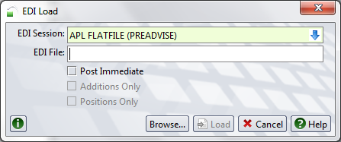

- Goto : Administration >> EDI >> Batches
- Select and double click sCurrent batch
- Select Process / Transaction tab to view the ERRORs

Screengrabs:

VGM weight updated in Units
